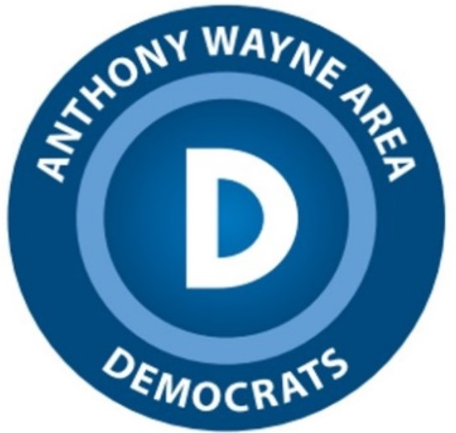
Anthony Wayne Area Democratic Club
Waterville, Ohio 43566-0212

The 2023 Anthony Wayne Area Democratic Club Scholarship, presented each year, will be awarded to the most deserving applicant who has demonstrated school and community commitment, who recognizes the importance of the democratic process, and who plans to continue their education or job training after graduating from Anthony Wayne High School.
PURPOSE: This scholarship shall be awarded to defray the cost of tuition, room and board, equipment or tools, books or supplies, while attending a post-secondary institution. The scholarship may be used for no other purpose.
ELIGIBILITY: Any graduating senior in the Anthony Wayne School District is eligible to apply during the year in which they will graduate, including those attending Penta Career Center. Children and grandchildren of members of the Anthony Wayne Area Democratic Club are not eligible to receive this award.
AMOUNT: One scholarship of $500 shall be awarded. This scholarship is an outright gift.
ANNOUNCING THE AWARD: The award shall be determined and announced in Spring, 2023, with the winner and family invited to our club meeting in May at the Waterville Public Library.
CRITERIA FOR DETERMINING THE WINNER:
- Original, personal essay that specifically addresses this question (60%)
As a graduating senior, you will now be eligible to actively participate and vote in future elections. Very exciting!

(maximum 500 words). Using personal life experiences and participation as a student and community member, explain how your involvement has made you more specifically aware of the democratic process. Because your generation will be the leaders in a short time, address how you would encourage young voters to take a more active part in democracy. What particular issues are you most concerned with and why?

- Character and personal involvement in school/ community (20%)
The applicant’s overall character, integrity, and honesty will be considered from the letters of recommendation, and from the submitted resume of school/community activities and work experiences.

C. Scholarship (20%)
Consideration shall be given to grade point average, class rank, and course or subject preparation for college or trade school, but also any demonstrated talent which may not be reflected in academic achievement. A higher GPA does not necessarily guarantee the applicant of a better chance of being awarded the scholarship.

Based upon the above criteria and possible personal interview, recipients from eligible applicants shall be chosen by the Scholarship Committee Chairperson and such committee members as designated by the AWADC. The decision of the committee will be final.
Time Schedule: Applications will be distributed in March, 2023. All applications must be completed and returned by Friday, April 14th, 2023. The selection process will be made in April with presentation on Wednesday, May 17, at our monthly club meeting. The Maumee Mirror will ask permission of you and parents/family for a photograph to share with readers.
All fully completed applications sent to:
Joe Puhl at Anthony Wayne High School or

Shellie McKnight
6950 Providence St.
Whitehouse, OH 43571

**Children and grandchildren of members shall include natural, adopted, or those under full custodial of guardian rights.

Anthony Wayne Area Democratic Club Scholarship Application: Make sure you complete all of the categories below, checking them off as you complete them or have them assembled. NO INCOMPLETE APPLICATIONS WILL BE CONSIDERED.

Name____________________________________________________________________
Address__________________________________________________________________

City ___________________________________ Zip code _________________________

Telephone number(s) _______________________________________________________

PLEASE ASSEMBLE THE FOLLOWING, checking them off as you assemble them:

____________________ Official Transcript (sealed)

____________________ 3 Letters of Recommendation (sealed) that must be from:

________ teacher (required)

________someone from your community (required)

________one additional person (NOT a relative)

____________________ Resume with dates of school involved clubs/sports/arts, etc., including offices you held, honors received, work experience, community involvement (youth groups, church, scouts, etc.)

____________________ a 500 word maximum essay that is original, NOT a cut and paste effort from other scholarship applications, and one that SPECIFICALLY addresses the question ABOVE.

YOUR POST GRADUATION PLANS

______________________________________ name of college, university or job training facility you plan to attend

______ accepted _____ pending acceptance _______ not yet applied

___________________________________________What is your intended area of study

I understand that this scholarship of $500 will be awarded to a graduating high school senior who resides in and attends the Anthony Wayne School District and that sons, daughters, and grandchildren of AWADC Members are not eligible for this award. I understand that I may be asked to meet with the scholarship committee to discuss my application. I understand that this scholarship is an out-right grant and that the decisions of the scholarship committee are final.

I also understand that the amount of the scholarship, should I be chosen, will be used for the sole purpose of defraying educational expenses and that, if chosen, I will be asked to attend a meeting of the Anthony Wayne Area Democratic Club (along with parent(s) or guardian(s) for presenting the scholarship.

________________________________________________ Your signature

_______________________ date submitted

